**REPORT AI LAB 4**

1. To represent a Sudoku puzzle as a CSP, we can create 81 variables, one for each cell in the grid. The domain of each variable will be the numbers 1-9.

Next, we need to define the constraints. The constraints in a Sudoku puzzle are that no two cells in the same row, column, or 3x3 square can have the same value. We can represent these constraints as binary constraints between pairs of variables. For example, we can create a constraint between the variables representing cells (i,j) and (k,l) if they are in the same row, column, or 3x3 square and the variables have the same value.

One option for implementation is to use the **CSP** class provided in the **csp.py** file. We can modify the **initialize** function to create variables and constraints based on the input Sudoku puzzle.

For backtracking search, we can implement the **backtracking_search** function in the **search.py** file. We can use the **CSP** class and the **min_conflicts** function provided in the **util.py** file to implement the backtracking search algorithm.

For AC-3 search, we can implement the **AC3** function in the **search.py** file. We can use the **CSP** class and the **Queue** data structure provided in the **util.py** file to implement the AC-3 search algorithm.

To output the solutions in the same format as the input files, we can read in each line from the input file, solve the Sudoku puzzle using the backtracking or AC-3 search algorithm, and output the solution as a string of 81 digits, followed by a newline character. We can group the solutions by the input file they came from and label them as "Euler" or "Magic Tour" as instructed.

2. My experience while working on this assignment was to develop an algorithm to solve all 145 puzzles in the same format as the input files, and I felt happy when I found it.

The last number of problems sovled the number is: 50

The time taken to slove the puzzle in the 50th problem is 0.7251501083374023

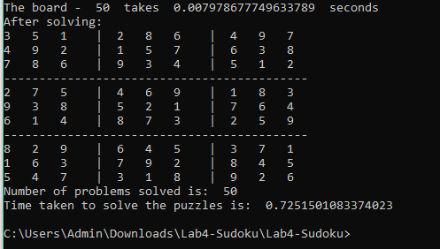

3. About 2 days, I was struggling about the command which has been given by the question and the cmd always report that my command was invalid.

The given command:

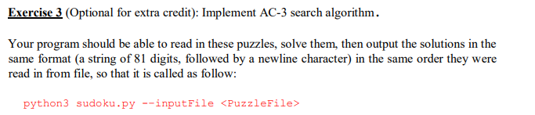

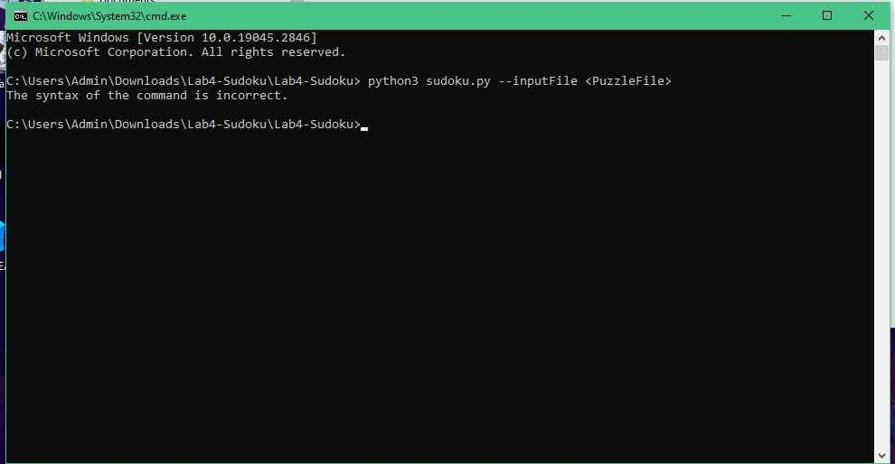

My command after fixing:

